PropertyShark users can upload property images and receive a free Nationwide Elite subscription, which grants access to 500 property reports for 30 approved photos in NY state or 40 approved photos Nationwide.

To ensure uploaded images meet our standards and are accepted, we've created a comprehensive guide. This guide outlines essential techniques and considerations for creating visually appealing and informative images that showcase a property's best features. We strongly recommend following these recommendations to avoid common pitfalls and ensure your photos are accepted.

Photo Guidelines
- Dynamic Perspective
  - Use side angles to reveal architectural details or property depth when the front view alone does not capture the essence of the property.
  - For corner lots, an angled shot that includes both sides of the building is ideal to emphasize its size and space. (See examples 7 and 8 below.)
  - Shoot in landscape mode; if not possible or appropriate, shoot in portrait mode.
- Framing
  - Ensure that the entire property is included in the shot, and no parts are left out (e.g. 11, 12).
  - Ensure that the vertical lines of the building remain perpendicular to the bottom of the frame to avoid perspective distortion (e.g. 1).
  - Photos should be close enough to clearly highlight the subject property (e.g. 2, 3, 4).
- Resolution
  - Photos should be high-resolution (at least 1024 x 680 pixels).
- Contrast and Clarity
  - Please be mindful of the brightness and avoid:
    - Photo overexposure — too much brightness (e.g. 4)
    - Photo underexposure — too little brightness (e.g. 5)
  - Make sure photos are high quality and clear. Blurred ones will not be accepted anymore (e.g. 6).
- Composition
  - Before shooting, make sure that there are no parked cars, garbage bins, trees, street signs, cables or any debris blocking key features of the property.(e.g. 4, 9, 10, 12).
    - Pay attention to the edges of the frame where unwanted elements can intrude.
    - If obstructions cannot be moved, find alternative angles to minimize their impact on the composition.
  - Try to capture some of the property's surroundings if they are an asset to the property's appeal (garden, garage).
  - Some obstacles are unavoidable, but moving obstacles (cars, bicycles, buses, etc.) should be excluded.
- Optimal Lighting Conditions
  - Ideally, choose a day with clear skies or a few clouds for outdoor photography to avoid flat lighting from overcast conditions.
Please submit only one photo per property angle. Duplicate/very similar photos will be rejected.
Watermarked photos will not be accepted.
Examples
EXAMPLE 1 - Photo is slightly crooked  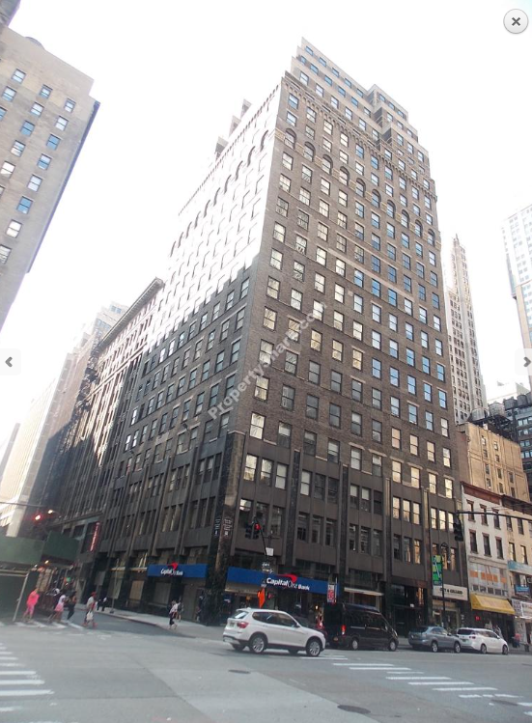 | EXAMPLE 2  - Good positioning, straight/level  - Excellent brightness  - The frame is too wide and too far. It’s not clear which property is the main subject  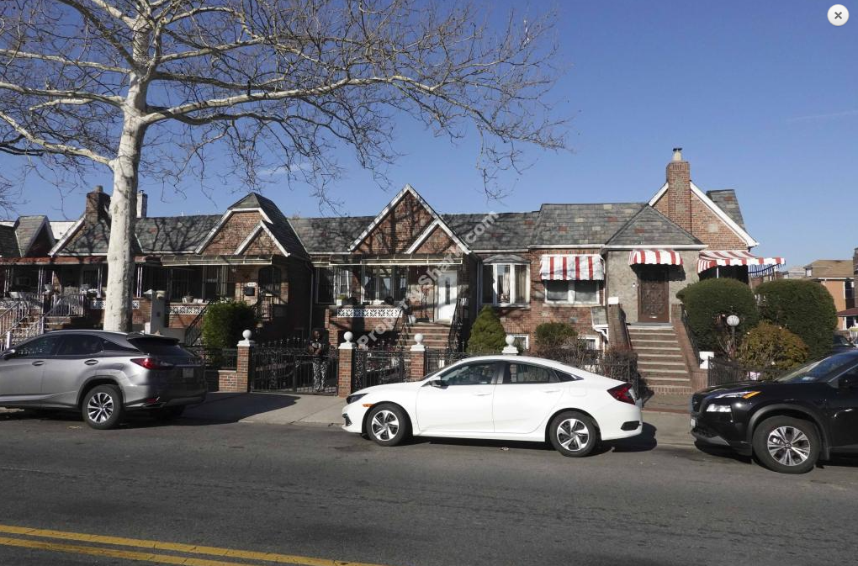
EXAMPLE 3  - The shot is too wide, it is not clear which property is the main subject here.  - There is a car in the photo forefront.  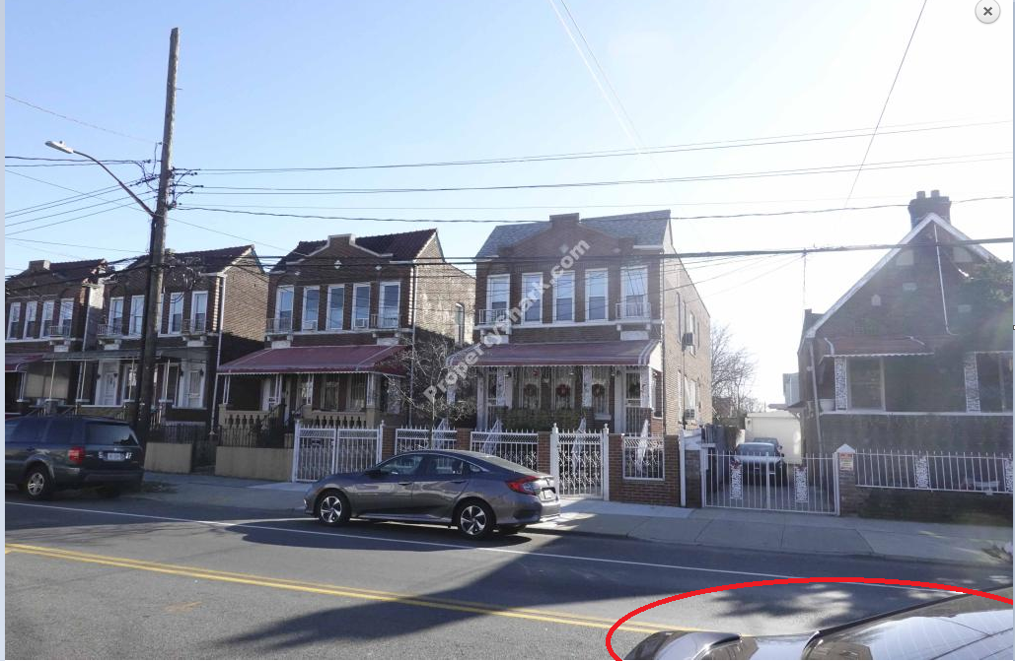 | EXAMPLE 4  - The photo is overexposed.  - There is a car top in the forefront and cables in the left corner.  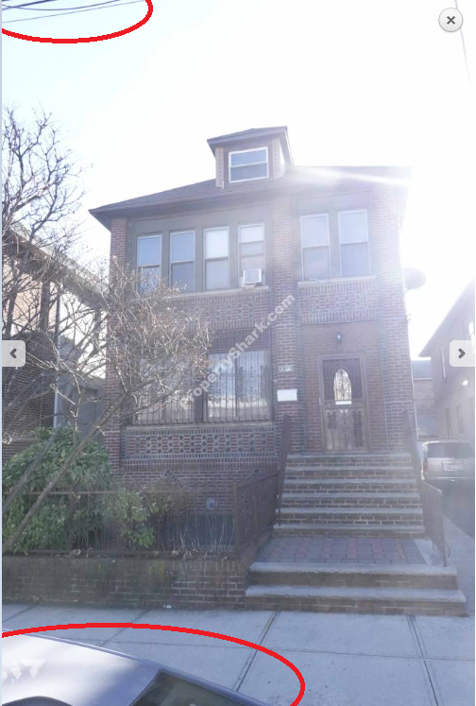
EXAMPLE 5 – The photo is too dark.  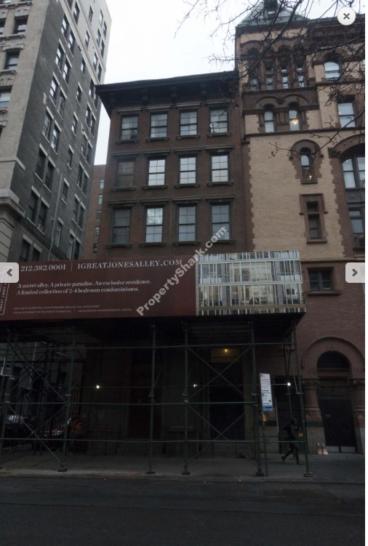 | EXAMPLE 6 – The photo is blurry.  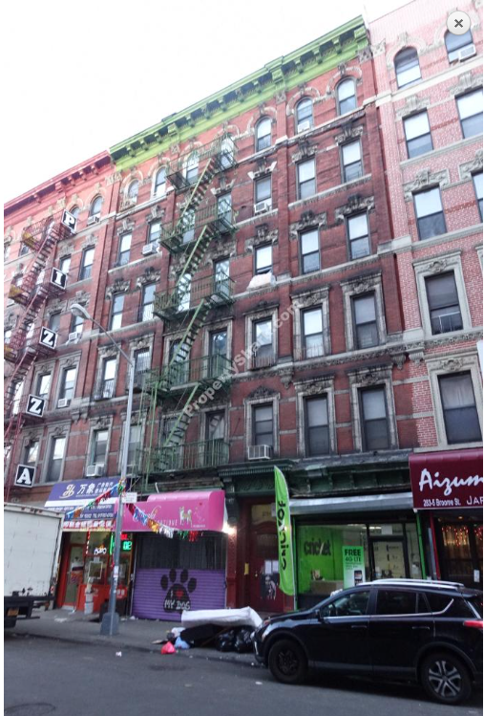
EXAMPLE 7 – Excellent angle for corner property; however, if possible, the left building should be left out of the frame  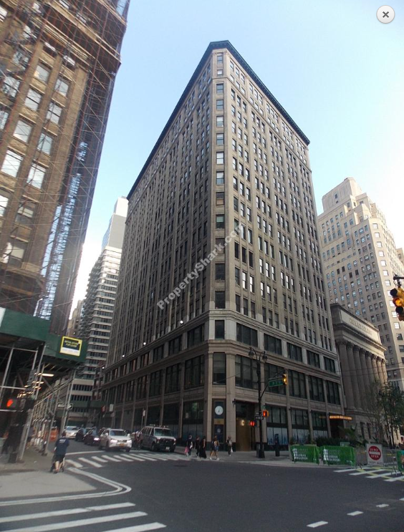 | EXAMPLE 8 – Excellent angle for corner property  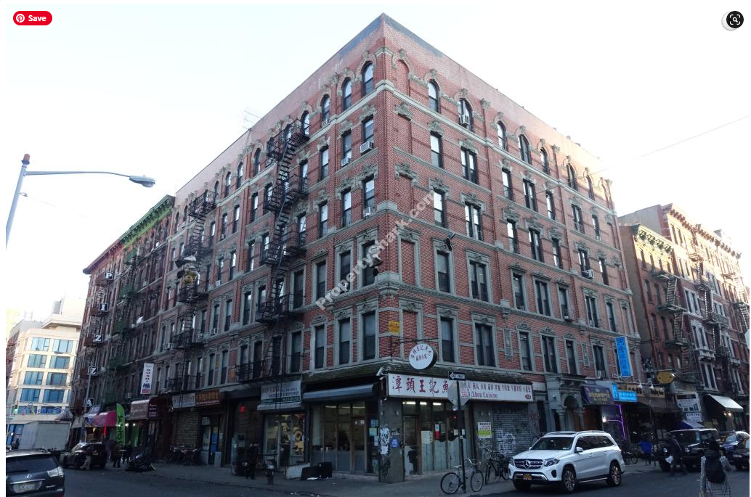
EXAMPLE 9 – There is a car stoplight in photo forefront  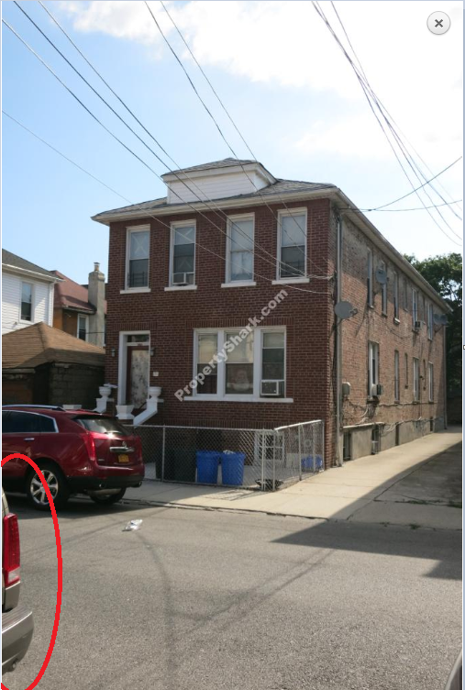 | EXAMPLE 10 – The frame includes lots of cables  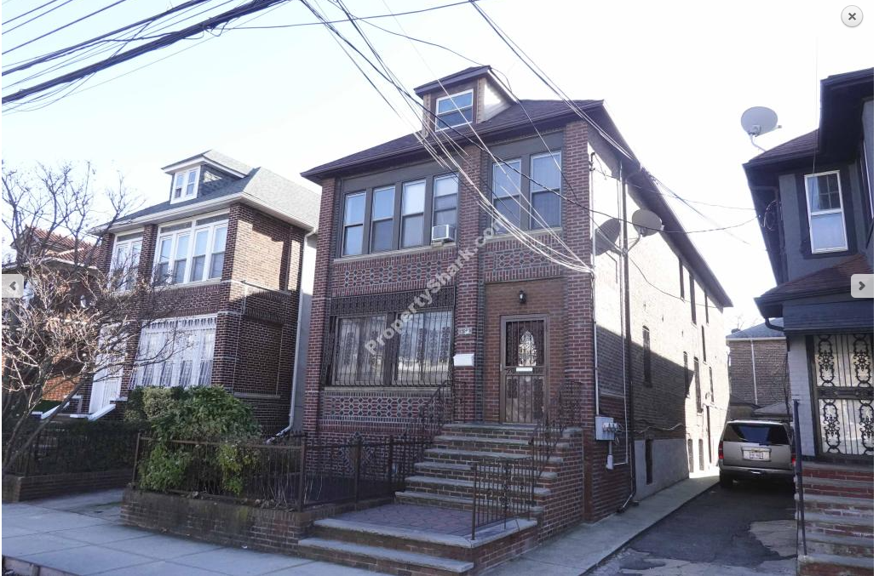
EXAMPLE 11 – The top of the building is left out  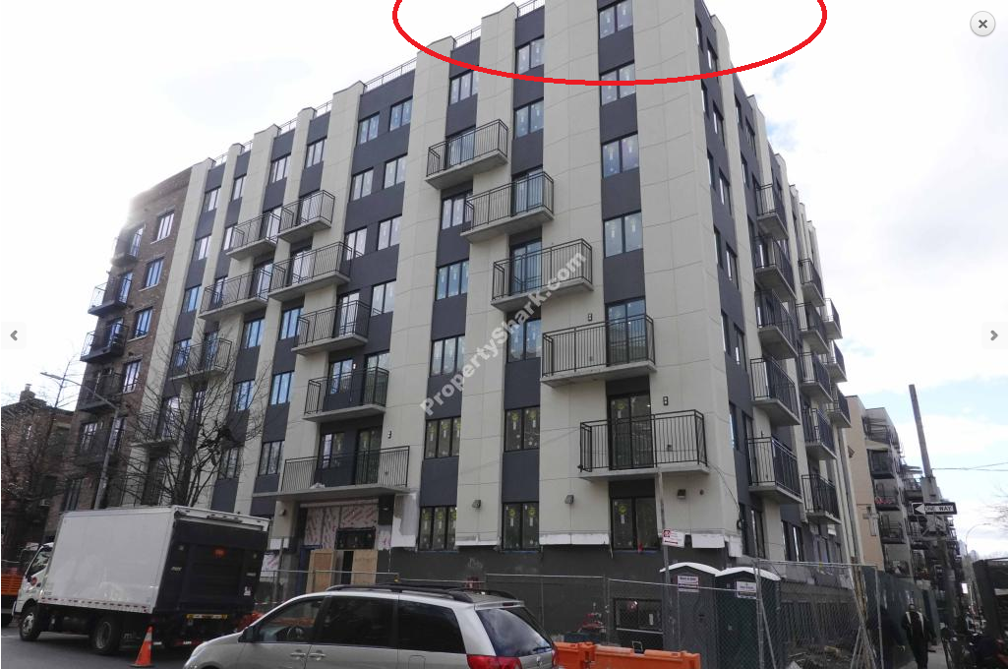 | EXAMPLE 12 – The building on the right is a major obstacle in the view  